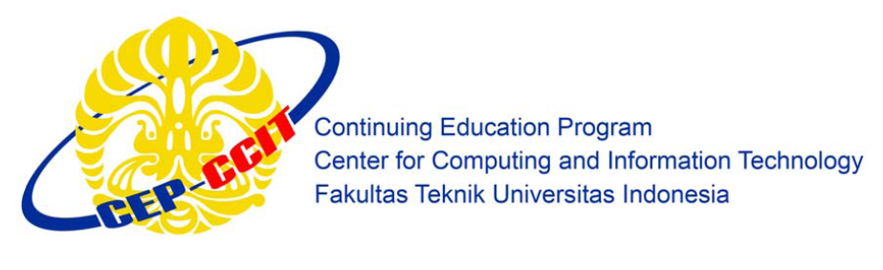

**Information Search and Analysis Skill  
  
(ISAS)**

**Implementation Cloud Storage Architecture on Google Drive**

Group 9

Name : Christian Frans Mukuan

Muladi Aprianto Manalu

Class : 3 SC 3

CEP CCIT

FAKULTAS TEKNIK UNIVERSITAS INDONESIA

2020

**PREFACE**

First of all, we want to thanks to Allah SWT because of his bless and grace, the entitled “Implementation Cloud Storage Architecture on Google Drive” can be finished on time as ISAS requirements 2020.

The paper is a requirement to fulfill the assignment from Mr. Riza Muhammad Nurman, as our faculty. And we also thanks to her for all the guidance to complete it.

We hope this paper can be usefully to all people and increase knowledge for all of us. We realize that this paper is still far from perfect in the arrangement or in the content of paper. We hope that the suggestion from all of you can be a support to make us better in the next ISAS.

Finally, we expect that it can be a medium for the reader to deepen the knowledge about the “Implementation Cloud Storage Architecture on Google Drive”.

Depok, December 10th 2020

Authors

TABLE OF CONTENTS

**PREFACE** 2

INTRODUCTION 2

1.1 Background 2

1.2 Writing Objective 2

1.3 Problem Domain 3

1.4 Writing Methodology 3

1.5 Writing Framework 3

BASIC THEORY 5

II.1 Definition of Cloud Computing 5

II.2 Types Of Cloud Computing 6

II.2.1 Software-as-a-service (SaaS) 6

II.2.2 Infrastructure-as-a-service (IaaS) 6

II.2.3 Platform-as-a-service (PaaS) 6

II.3 Definition of Cloud Storage 7

II.4 Definition Google Drive 8

PROBLEM ANALYSIS 10

III.1 Cloud Storage Architecture on Google Drive 10

III.2 Work Flow Cloud Storage Architecture on Google Drive 12

III.3 Advantages and Disadvantages of using Google Drive 13

CONCLUSION AND SUGGESTION 15

4.1 Conclusion 15

4.2 Suggestion 15

BIBLIOGRAPHY 16

TABLE OF FIGURES

Figure 1 : Definition Cloud Computing 5

Figure 2 : Cloud Storage Component 7

Figure 3 : What is Google Drive? 8

Figure 4 : Cloud Storage using Google Drive 11

Figure 5 : Workflow Cloud Storage Architecture 12

**CHAPTER I**

# INTRODUCTION

## Background

Google is the biggest and the best search engine today. Google is a large American company that provides products and services around the internet. Google was founded in 1998, precisely on September 4, 1998, Google was founded by students from Stamford University, America. Founded by Larry Page and Sergey Brin, they are both very friendly to each other. they both have 17% stake in Google company Larry Page and Sergey Brin made Google a private company in 1998, they both have the same mission, which is to collect all information for their search engine so that it can make it easier for everyone, especially internet users to find information. Since its founding, Google has grown and grown rapidly.

Google also produces several products and services. Namely, Google Translate is an internet dictionary created by Google to make it easier for internet users to translate a language or a sentence. Google Maps is a product from Google to make it easier for internet users to find a location or place, Google Drive is a cloud computing-based service that can be used to create, share, collaborate and store data up to 1 terabite (TB). According to Google's representative, Sundar Pichai, Drive allows users to upload and Google Drive is a change from Google Docs, if you open Google Docs it will be redirected to Google Drive, access various files such as videos, photos, Google Docs and PDFs.

## 1.2 Writing Objective

The purpose of writing this paper entitled Implementation Cloud Storage Architecture on Google Drive is to work on tasks related to the Information Systems Architecture and to learn more about Google Drive.

## 1.3 Problem Domain

Accordance with the title of ISAS “Implementation Cloud Storage Architecture on Google Drive“, authors will discuss about:

1. To know understanding about Implementation Cloud Storage Architecture on Google Drive.
2. To know the work principle of Cloud Storage Architecture on Google Drive.
3. To know the advantages and disadvantages of Google Drive.

## 1.4 Writing Methodology

The writing method that we use is a method of literature review, which is the collection of materials to be used and then analyzed from trusted sources.

## 1.5 Writing Framework

To facilitate writing of the ISAS, this discussion was organized into systematics as follows.

**Chapter I : Introducing**

In chapter will discuss about background, writing objective, problem domain, writing methodology used, and writing framework about this ISAS.

**Chapter II : Basic Theory**

In chapter II will discuss about definition of Cloud Computing, types of Cloud Computing, definition of Cloud Storage, and Definition of Google Drive.

**Chapter III : Problem Analysis**

In chapter III will discuss about overview of the theory that contains the answer to the problem formulation in chapter one, Cloud Storage Architecture on Google Drive, Work Flow Cloud Storage Architecture on Google Drive, the Advantages and disadvantages of Google Drive.

**Chapter IV : Conclusion and Suggestion**

In chapter IV contains the conclusions obtained after analyzing about Implementation Cloud Storage on Google Drive and giving a suggestion to readers about Implementation Cloud Storage on Google Drive.

**CHAPTER II**

# BASIC THEORY

## II.1 Definition of Cloud Computing

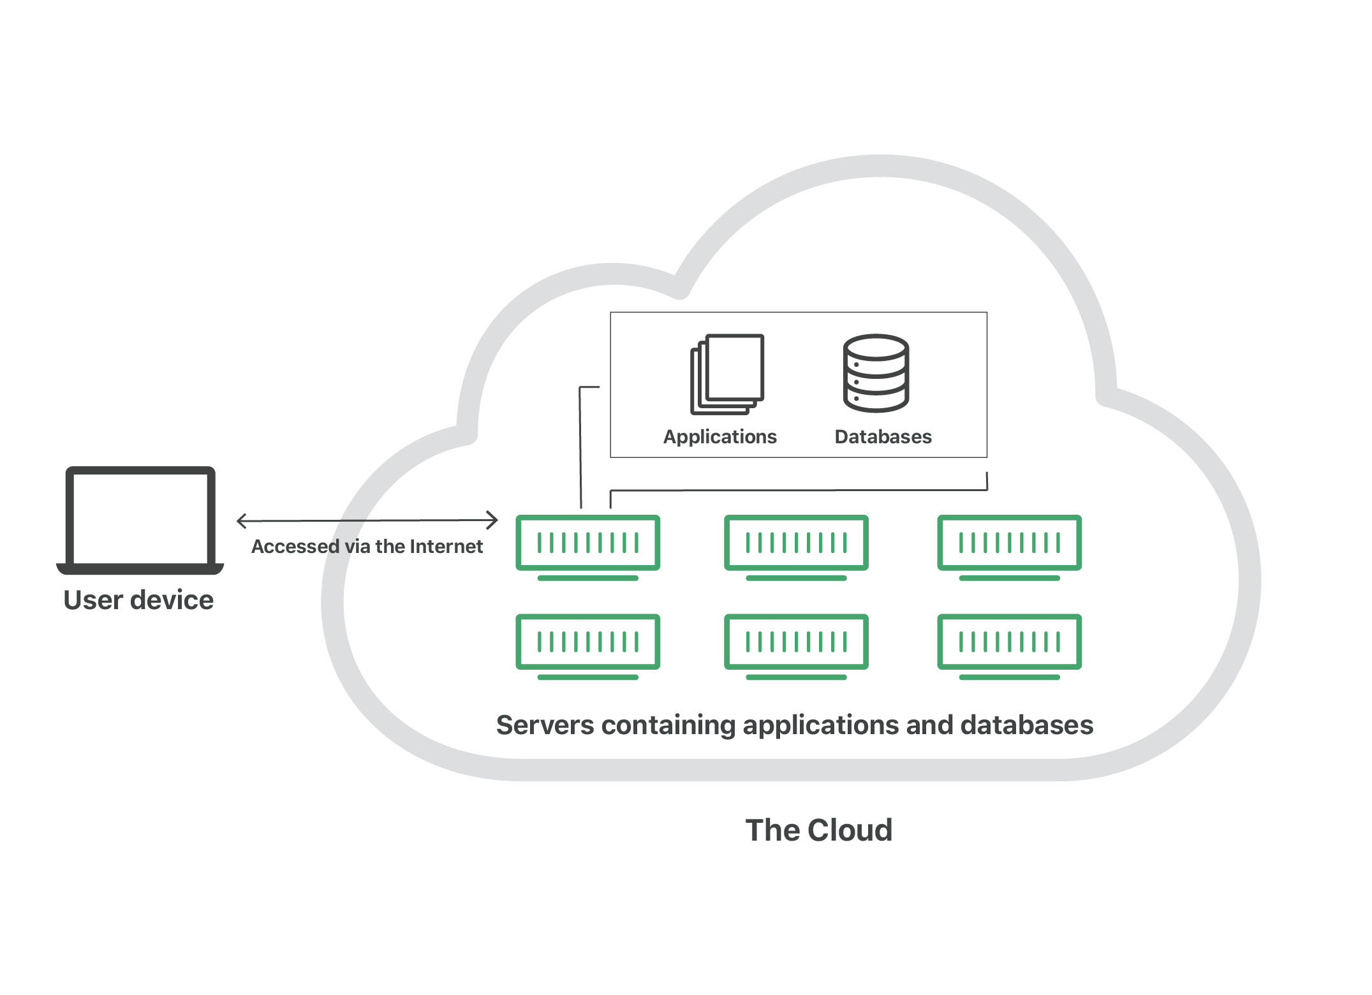

*Figure 1 : Definition Cloud Computing*

Cloud Computing is a term from the Cloud which is defined as the internet and Computing is defined as a computer. The definition of Cloud Computing is a process of processing computing power through the internet network which has the function of being able to run programs through computers that are connected to each other at the same time.

Cloud computing is the delivery of different services through the Internet. These resources include tools and applications like data storage, servers, databases, networking, and software.

Rather than keeping files on a proprietary hard drive or local storage device, [cloud-based storage](https://www.investopedia.com/terms/c/cloud-storage.asp) makes it possible to save them to a remote database. As long as an electronic device has access to the web, it has access to the data and the software programs to run it.

Cloud computing is a popular option for people and businesses for a number of reasons including cost savings, increased productivity, speed and efficiency, performance and security.

## II.2 Types Of Cloud Computing

Cloud computing is not a single piece of technology like a microchip or a cellphone. Rather, it's a system primarily comprised of three services: [software-as-a-service (SaaS)](https://www.investopedia.com/terms/s/software-as-a-service-saas.asp), infrastructure-as-a-service (IaaS), and platform-as-a-service (PaaS).

### II.2.1 **Software-as-a-service (SaaS)**

Software-as-a-service (SaaS) involves the licensure of a software application to customers. Licenses are typically provided through a pay-as-you-go model or on-demand. This type of system can be found in Microsoft Office's 365.

### II.2.2 Infrastructure-as-a-service (IaaS)

Infrastructure-as-a-service (IaaS) involves a method for delivering everything from operating systems to servers and storage through IP-based connectivity as part of an on-demand service. Clients can avoid the need to purchase software or servers, and instead procure these resources in an [outsourced](https://www.investopedia.com/terms/o/outsourcing.asp), on-demand service. Popular examples of the IaaS system include IBM Cloud and Microsoft Azure.

### II.2.3 Platform-as-a-service (PaaS)

Platform-as-a-service (PaaS) is considered the most complex of the three layers of cloud-based computing. PaaS shares some similarities with SaaS, the primary difference being that instead of delivering software online, it is actually a platform for creating software that is delivered via the Internet. This model includes platforms like Salesforce.com.

## II.3 Definition of Cloud Storage

The cloud storage refers to the service in which user data is remotely maintained, managed as well as backed up or stored. The service is usually available to the users over internet. In this concept, user will store the files online using internet to the external servers maintained by the cloud storage service providers. Once the files are stored, these can be accessed from anywhere in the world with the use of internet.

Cloud storage provides user ease and convenience to handle the data backup and retrieval. Here user need not have to keep pen drive or carry hard disk along with him on travel. But, this will often add to the cost of the users to utilize the cloud storage services for large amount of data storage. Moreover cloud storage is much slower compare to local storage backup for the huge amount of data.

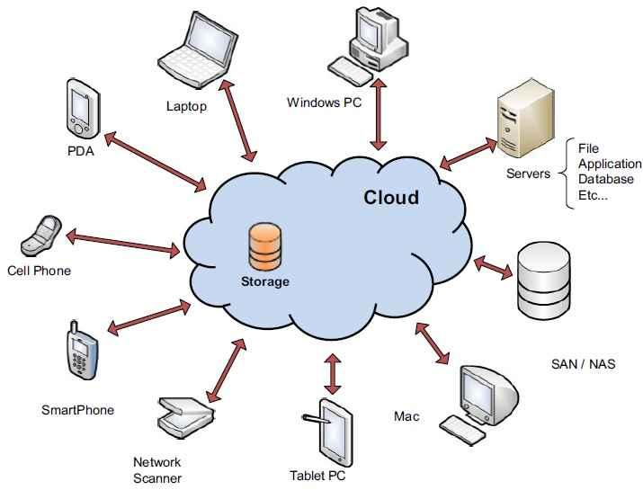

*Figure 2 : Cloud Storage Component*

Logically there are two main components in this system viz. cloud drive and IP enabled devices (such as laptop, desktop, mobile phones). The IP device and cloud drive get synchronized as and when data is dragged and dropped in the folders of the cloud drive available remotely. The cloud data storage services are free to store data up to few GBs. After free data limit, it will be charged on monthly basis. Figure-1 depicts user devices or applications of cloud storage.

A good cloud storage provider will have data redundancy, storing the same files in multiple physical locations so that it survives any human errors, equipment failures, or natural disasters. The popular cloud storage options are outlined below:

1. Dropbox (Provides 2GB free cloud storage)
2. Google Drive (Provides 15GB free cloud storage)
3. Microsoft Skydrive (Provides 7GB free storage)
4. Box (Provides 5GB free)

## II.4 Definition Google Drive

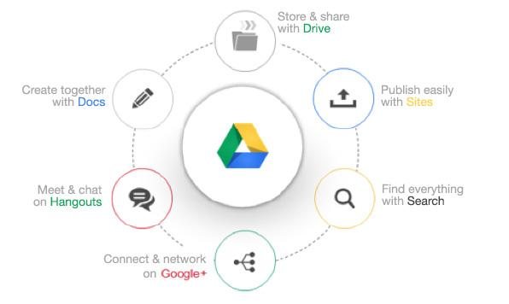

*Figure 3 : What is Google Drive?*

Google Drive is a service offered by [Google](https://techterms.com/definition/google) that allows you to store and share [files](https://techterms.com/definition/file) online. The service was launched on April 24, 2012 and provides 5 GB of free storage. Additional storage can be purchased for a monthly fee.

The goal of Google Drive is to provide a central place to store your files [online](https://techterms.com/definition/online) so that you can access them from anywhere. Additionally, you can access your Google Drive from multiple devices, since the software is available for [Windows](https://techterms.com/definition/windows), [Mac OS X](https://techterms.com/definition/os_x), [Android](https://techterms.com/definition/android), and [iOS](https://techterms.com/definition/ios) platforms. The service also provides a web-based interface that allows you to organize your files and search for documents by [filename](https://techterms.com/definition/filename) or content.

Besides online file storage, Google Drive provides tools for sharing files and collaborating on projects with other users over the [Web](https://techterms.com/definition/www). For example, instead of emailing large attachments, you can send links to the files from your Google Drive to one or more users. You can also use the web-based Google Docs [applications](https://techterms.com/definition/application) to create or edit [documents](https://techterms.com/definition/document) online. When you share a document with other Google Drive users, everyone can view and edit the document at the same time.

Google Drive allows you to view over 30 [file types](https://techterms.com/definition/file_type) directly in your web browser. These include Google's proprietary formats, as well as other popular file types, such as Adobe Photoshop and Illustrator documents.

**CHAPTER III**

# PROBLEM ANALYSIS

## III.1 Cloud Storage Architecture on Google Drive

Regarding its architecture, Google Drive displays a typical client-server model. It, in server-side, provide service-based access to application data for users, in client-side. As what Professor Irvine says, it can be considered as a “hypertext” system. The process that users upload, store and download the files is actually a process of encoding and decoding between Web browsers and individual devices.

Meanwhile, sharing is one of the main features of Google Drive, which connect unlimited users through its servers. Files sharing can be easily accomplished via public folders or shared links. Also, simultaneous editing is another form of “sharing”. Rather than isolated, users are closely connected although they upload and edit the files on their own devices in different locations. This shows that Google Drive builds up a distributed network system across unlimited client/server implementations. In addition to website interface, it also offers apps available for Windows and macOS computers, and Android and IOS mobile phones and tablets. It means that it provides a model of interoperability for any software or hardware manufacturer.

## https://blogs.commons.georgetown.edu/cctp-820-fall2018/files/2018/11/1-600x481.png

Furthermore, synchronization is another core services. Its current Backup and Sync service can automatically upload files from individual devices to their drives when devices connect to the Internet. Also, real-time file sync works when users edit the files online, which means that behind the screen, the backup process remains unstopped.

At last, for its media function, a web-based office suite, including Docs, Sheets, and Slides, is integrated into Google Drive. It allows users to create and edit documents, spreadsheets, and presentations online while collaborating in real-time with other users. Also, multiple forms of files and media can be viewed on the web.

## III.2 Work Flow Cloud Storage Architecture on Google Drive

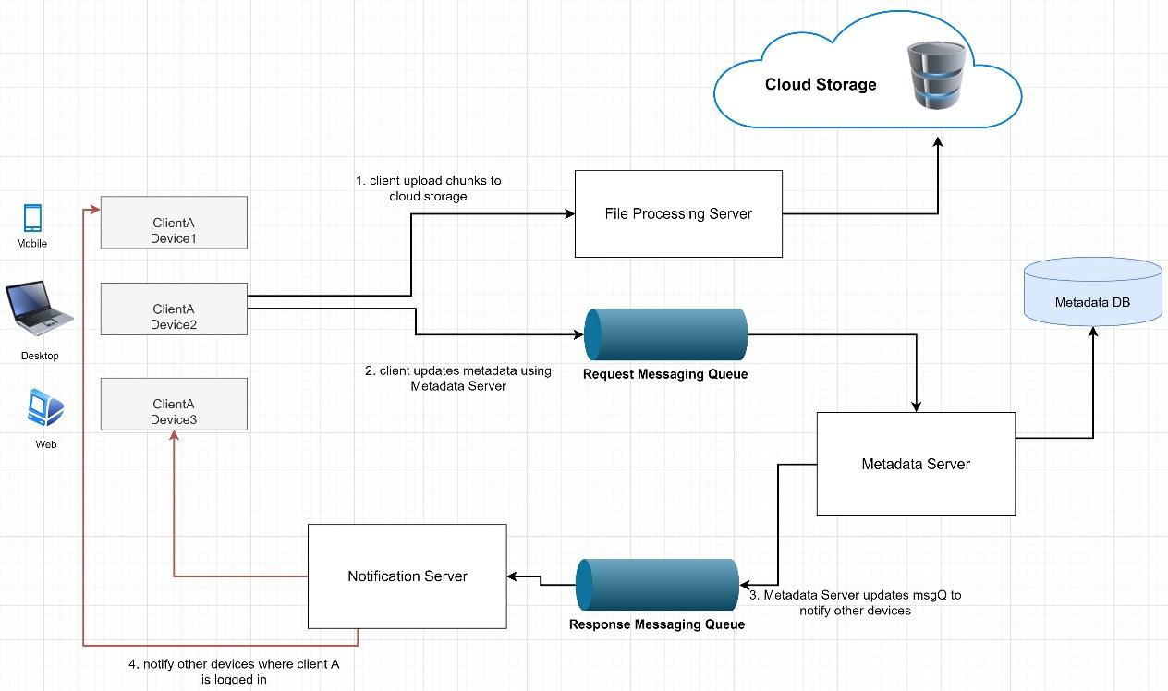

*Figure 5 : Workflow Cloud Storage Architecture*

It stores files(chunks) uploaded by the users. Clients can interact with the storage through File Processing Server to send and receive objects from it. It holds only the files; Metadata DB keeps the data of the chunk size and numbers of a file.

Client A uploads chunk to cloud storage. Client A updates metadata and commits changes in MetadataDB using the Metadata server. The client gets confirmation, and notifications are sent to other devices of the same user. Other devices receive metadata changes and download updated chunks from cloud storage.

We can store file-chunks in partitions based on the first letter of the File Path. For example, we keep all the files starting with the letter ‘A’ in one partition and those beginning with the letter ‘B’ into another partition and so on. This is called range-based partitioning. Less frequently occurring letters like ‘Z’ or ‘Y,’ we can combine them into one partition.

In this system, we did not consider the UI part. The history of the updates and offline editing was also not considered in the system. The mobile client could sync on-demand to save the user’s bandwidth and space. Here we did not use another server for synchronization. The Metadata Server is performing that task.

In cloud storage architecture, the privacy and security of user data are essential. We can store the permissions of each file in the metadata DB to check which files are visible or modifiable by which user.

## III.3 Advantages and Disadvantages of using Google Drive

Google Drive is like a server or place where you can store all your files and data into it safely. You can store all your files such as videos, photos, Google Docs, PDFs and etc. It can be managed by either individual or joint venture, both parties can manage the files in a joint project. And this is the advantages and disadvantages of Google Drive.

The advantages of Google Drive include:

1. **Access your files everywhere** – Google stores your files in their server and you can access them no matter where you are as long as you are able to access to internet.
2. **You can edit and make changes to the files** – Google Drive gives you instant access to Google Docs, a suite of editing tools that allow you to edit and make changes to your files.
3. **Able to access with various devices** – You can simply access to Google Drive and access your files anytime and anywhere as long as you have a device on hand with network, it is access-able with various devices such as PC, Mac, iPhone, iPad and Android devices.
4. **View any types of file** – Google Drive can opens any types of file such as HD video, Adobe Illustrator and Photoshop, there are up to 30 file types in your browser. The best thing is that you don’t have to install or own this file type in your PC.
5. **15GB Free Disk Space** – You can get started with 15GB of disk space, it’s free! You can store everything you want with this 15GB of disk space, you can choose to upgrade to 25GB for $2.49/month, 100GB for $4.99/month or even 1TB for $49.99/month. When you upgrade to a paid account, your Gmail account storage will also expand to 25GB.

The disadvantages of Google Drive include:

1. **Dependency on Internet Speed** – If the Internet connection is slow or unstable, we might have problems accessing or sharing the files.
2. **Dependency on a Third Party** – A third party service provider (company) is responsible for the data stored and hence it becomes an important pre-requisite in selecting a vendor and to examine the security standards prior investing.
3. **High Cost for Huge Data** – Require a large amount of storage may also find costs increase significantly even after the first few gigabytes of data stored.

**CHAPTER IV**

# CONCLUSION AND SUGGESTION

## 4.1 Conclusion

Google Drive with a great deal of promise, aren’t designed to be high performing file systems but rather extremely scalable, easy to manage storage systems. They use a different approach to data resiliency, Redundant array of inexpensive nodes, coupled with object based or object-like file systems and data replication (multiple copies of the data), to create a very scalable storage system.

## 4.2 Suggestion

While there are issues of non-uniformity across cloud vendors there is a requirement to provide uniform user interfaces and seamless integration with the mainstream desktop and server computing. Moreover, since a cloud infrastructure is a distributed system, storage facilities may be designed like the distributed file system.

.

# BIBLIOGRAPHY

**[1]** [**Vladimir Zwass**](https://www.britannica.com/contributor/Vladimir-Zwass/4614). *Information System.* Retrieved 29 September 2020

<<https://www.britannica.com/topic/information-system>/>

**[2] Bryan R.** *System Architecture.* Retrieved 29 September 2020

**<**<https://www.coursehero.com/file/p75k84a/System-Architecture-A-system-architecture-is-a-conceptual-model-that-defines/>**>**

**[3] Ioan Raicu.** *Distributed System Architecture.* Retrieved 29 September 2020

**<**<http://www.cs.iit.edu/~iraicu/teaching/CS550-S11/lecture04.pdf>**>**

**[4]** [**Gurudatt Anil Kulkarni**](https://www.researchgate.net/profile/Gurudatt_Kulkarni)**.** *Cloud Storage Architectue.* Retrieved 29 September 2020

**<**<https://www.researchgate.net/publication/239732057_Cloud_Storage_Architecture>>

**[5] Lisa Morgan.** *How Does Cloud Storage Work?*

Retrieved 30 September 2020

**<**<https://www.enterprisestorageforum.com/cloud-storage/how-does-cloud-storage-work.html>**>**

**[6] Developer Google.** *Introduction to Google Drive API.* Retrieved 30 September 2020

**<**<https://developers.google.com/drive/api/v3/about-sdk>>

**[7] Okto.** *Cloud Storage vs. Cloud Computing: What’s the Difference?.* Retrieved 30 September 2020

**<**<https://info.cloudcarib.com/blog/cloud-storage-vs.-cloud-computing-whats-the-difference>>